Week 12 Story Time: Spend time with your family
My name is………………………..
2nd Grade A & B - Miss Lucía and Miss Sofía
Esta semana vamos a leer una historia. ¿Están listos? ¡Vamos!
Let’s watch!
Watch the video with Miss Sofia from 2nd Grade A. Let’s enjoy the story! Click here:
Miremos el video con Miss Sofía de 2do Grado A. ¡Disfrutemos la historia!
(Lo pueden mirar en cualquiera de los dos links!)
https://drive.google.com/file/d/1nWfyUA5tfzHKg3PCY0k3NyeUQeQuR1Wu/view?usp=sharing
https://youtu.be/oc-eN_U7ARM

Complete the activities!
Completar las actividades
- Read and colour. Then match.
Leé y coloreá. Luego, uní con flechas.
- Where is Charlie’s grandad?
He’s in the flat / shop.
- Where is Charlie’s mum?
She is in the garden / bathroom.
- Where is Charlie’s uncle?
He is in the shop / kitchen
- Where is Charlie’s aunt?
She is in the attic / library.
- Read and write.
Leé y escribí.
- How many aunts have you got?
I’ve got ……..
- How many uncles have you got?
……
- How many cousins have you got?
…..
- How many grandads have you got?
……

- Your turn!
Read the story! ¡Leé la historia!
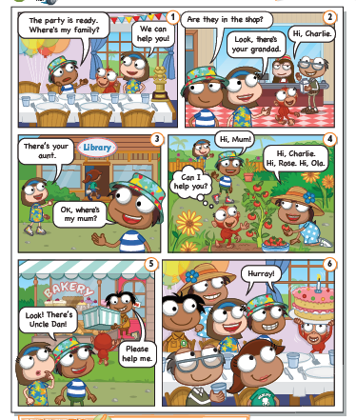
Subí un video o audio leyendo la historia a padlet!
Pueden ver las producciones de sus compañeros en el siguiente link a Padlet:

2do Grado A: https://padlet.com/segundoa3/s3kojehnfuxo621h
2do Grado B: https://padlet.com/segundob3/ti7cnz99eo1qgu06.
¡Esperamos que lo disfruten!

