Esta semana vamos a responder preguntas sobre personajes de dibujos animados y nuestros compañeros de clase. ¿Están listos? ¡Empecemos!
Watch the video with Miss Lucía from 3rd Grade B. Let’s learn together! Click here:
https://drive.google.com/file/d/1Jrz2T-5CeHcisHABf-2Y7BD0PFAsqw7Z/view?usp=sharing

Miremos el video con Miss Lucía de 3er Grado B. ¡Aprendamos juntos!

Let’s practice!
¡Practiquemos!
Me! | A GIRL | A BOY
Have you got brown hair?  - Yes, I have.  - No, I haven’t. | Has she got brown hair?  - Yes, she has.  - No, she hasn’t. | Has he got brown hair?  - Yes, he has.  - No, he hasn’t.

- About Miraculous! Look at the GIRL characters and answer with YES, SHE HAS or NO, SHE HASN’T.
¡Sobre Miraculous! Mirá solamente a los personajes que son chicas y respondé a las preguntas con YES, SHE HAS o NO, SHE HASN’T.

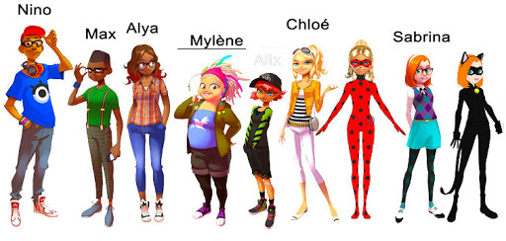

- Has Chloé got blonde hair? _________________________________
- Has Sabrina got brown eyes? _______________________________
- Has Alya got red hair? ____________________________________
- Has Mylène got grey hair? _________________________________
- Has Alix got blue eyes? ___________________________________

Look at the BOY characters and answer with YES, HE HAS or NO, HE HASN’T.
Mirá solamente a los personajes que son chicos y respondé a las preguntas con YES, HE HAS o NO, HE HASN’T.

- Has Max got small glasses? ________________________________
- Has Nino got a black moustache? ___________________________
- Has Max got brown hair? __________________________________
- Has Nino got black eyes? __________________________________

- About your friends! Remember your classmates and answer with YES, HE/SHE HAS or NO, HE/SHE HASN’T.
¡Sobre tus amigos! Recordá a tus compañeros de clase y respondé con YES, HE HAS/NO, HE HASN’T si es niño y YES, SHE HAS/NO, SHE HASN’T si es niña.

- Has Martina got blonde hair? _____________________________
- Has Antonino got small glasses? ___________________________
- Has Sofía got blonde hair? ________________________________
- Has Ignacio got blue eyes? _______________________________
- Has Juan Cruz got a short beard? __________________________
- Has Luciana got red hair? ________________________________

Your turn!

Choose a girl and a boy classmate and descriptions them. Add a photo or drawing with the description. You can write or record your description.

Upload your photo with the written or oral description in Google Drive, folder 3rd B or A. We will then publish in Padlet your creations.

Model:

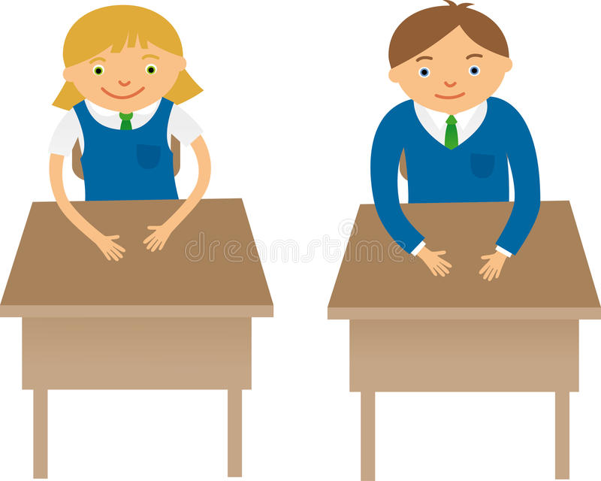
- She is Ana.
She’s got blonde hair.
She’s got green eyes.
She hasn’t got small glasses.

- He is Juan.
He’s got brown hair.
He’s got blue eyes.
He hasn’t got a black moustache.

Elegí un compañero y una compañera de clase y describilos. Agregá una foto o dibujo con tu descripción. La descripción puede ser escrita u oral.
Subí una foto o dibujo con tu descripción escrita u oral en Google Drive, 3er Grado y elegí tu curso A o B. Después, las profes subiremos sus creaciones a Padlet.

Usuario: englishprimaryCJCC@gmail.com
Contraseña: Ingles2020

Pueden ver las producciones de sus compañeros en el siguiente link a Padlet:

3ero A: https://padlet.com/terceroa3/k95i4pu4frykq8tl
3ero B: https://padlet.com/tercerob3/1y88jc06tfiv6sub.

A medida que nos lleguen y suban nuevas producciones, las iremos compartiendo.

¡Esperamos que lo disfruten!

